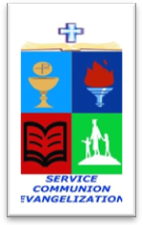
ROMAN CATHOLIC BISHOP OF NOVALICHES
EDUCATIONAL SYSTEM (RCBN-ES, Inc.)
Quirino Highway cor. P. dela Cruz St., Novaliches, Quezon City
Telephone 417-3105

POINTERS TO REVIEW IN SCIENCE 4
School Year 2017 – 2018

FOURTH QUARTER

I. Types of Soil

II. Sources of Water in the Community
A. Water Cycle
B. Importance of Water
C. Ways of Conserving Water
D. Components of Weather
E. Weather Chart
F. Precautionary Measures Before the Typhoon
G. Precautionary Measures During the Typhoon
H. Precautionary Measures After the Typhoon

III. Nature and Importance of the Sun
A. Beneficial Effects of the Sun on living things
B. Harmful Effects of the Sun on Living Things
C. Safety Precautions

